Corey Gaspar
3/22/2026
3-2 Assignment: Android Studio Introduction
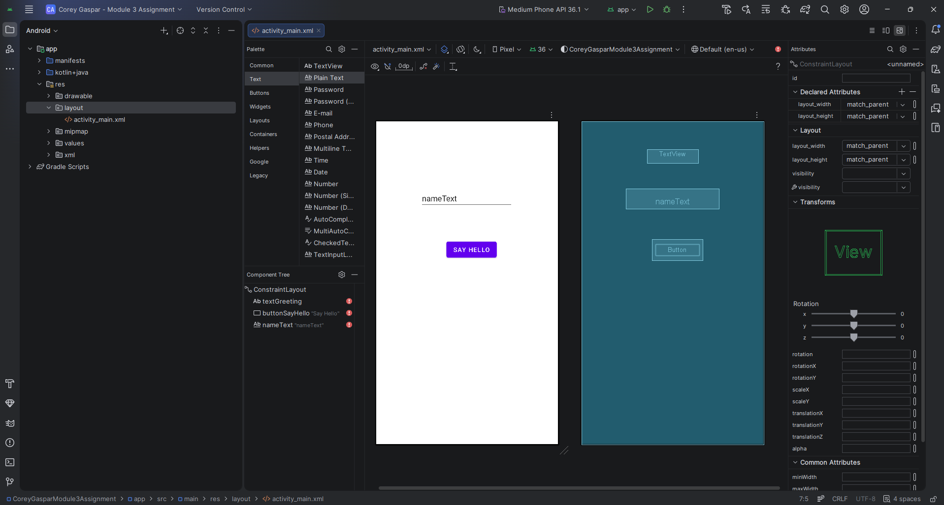
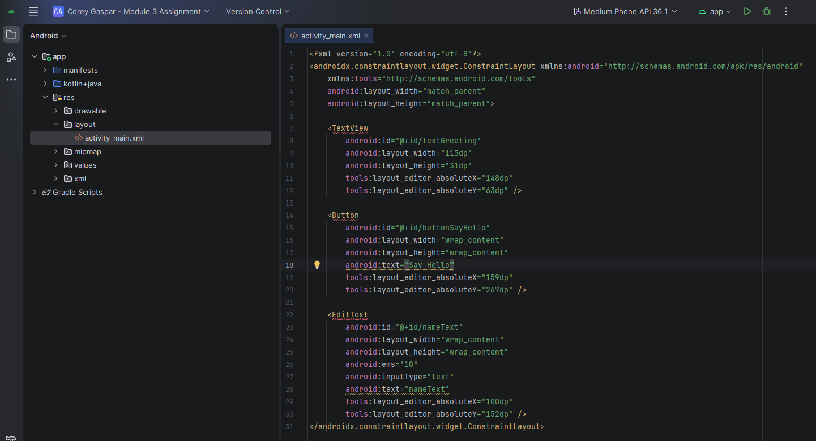
My initial experience with Android Studio was a bit challenging but also interesting as well. The initial setup process was fairly straightforward, but I didn’t realize that it was still downloading dependencies so it was taking some time to load. Setting up the layout folder was a little challenging as well since there’s no option to create a layout folder. Instead, I had to create an Android Resource Directory and set it to layout. I then went on to create the main_activity.xml file, however when I first created it, I wasn’t able to drag buttons or any items onto the layout editor. So, I deleted the file and created a new Layout Resource File and it worked. Using the layout editor was interesting to me. At first, I wasn’t sure how to edit the ID or name of the items that I added to my layout. I thought you had to right-click on them to edit the properties, but I later found out that it’s done through the side bar on the right. Finally, I had a hard time understanding how to switch between the layout editor and code editor. I had to do some research online to understand the layout but I finally figured out that you can toggle between the options on the top right of the screen. Overall, Android Studio was a little challenging to navigate at first, but I am excited to start working with it.

